RubberBand!

A Titanium Butterflys Game



“An Elastic Experience” - Elastigirl Cosplayer, 2019

# 

# Table of Contents

1 Game Overview

2 High Concept

3 Unique Selling Points

4 Platform Minimum Requirements

5 Competitors / Similar Titles

6 Synopsis

7 Game Objectives

8 Game Rules

9 Game Structure

10 Game Play

10.1 Game Controls

10.2 Game Camera

10.2.1 HUD

10.2.2 Maps

11 Players

11.1 Characters

11.2 Metrics

11.3 States

12 Player Line-up

13 NPC

13.1 Enemies

13.1.1 Enemy States

13.1.2 Enemy Spawn Points

13.2 Allies / Companions

13.2.1 Ally States

13.2.2 Ally Spawn Points

14 Art

14.1 Setting

14.2 Level Design

14.3 Audio

15 Procedurally Generated Content

15.1 Environment

15.2 Levels

15.3 Artificial Intelligence NPC

15.4 Visual Arts

15.5 Audio

15.6 Minimum Viable Product (MPV)

16 Wish List

17 Asset Bibliography

17.1 Video Folder

17.1.1 Animations Folder

17.1.2 Audio Folder

17.1.2.1 Cutscene Scripts Folder

17.1.2.2 Sound Effects Folder

17.1.2.3 Soundtracks Folder

17.1.3 Prefabs Folder

17.1.4 Sprites Folder

17.1.5 UI Folder

17.2 Scenes Folder

17.3 Scripts Folder

# Game Development Team

## Members

### PRODUCER

Lauryn Jefferson, Tommy Cao, Guillermo Mata, Manuel Perez

### PRODUCTION MANAGER

Lauryn Jefferson, Tommy Cao, Guillermo Mata, Manuel Perez

### PRODUCTION COORDINATOR

Lauryn Jefferson, Tommy Cao, Guillermo Mata, Manuel Perez

### GAME DESIGNERS

Lauryn Jefferson, Tommy Cao, Guillermo Mata, Manuel Perez

### PROGRAMMERS

Lauryn Jefferson, Tommy Cao, Guillermo Mata, Manuel Perez

### AUDIO ENGINEERS

Lauryn Jefferson, Tommy Cao, Guillermo Mata, Manuel Perez

### UX TESTERS

Lauryn Jefferson, Tommy Cao, Guillermo Mata, Manuel Perez

# 1 Game Overview

**Title:** Rubber Band

**Platform:** PC Standalone

**Genre:** Platformer

**Rating:** (10+) ESRB

**Target:** Casual gamer

**Release date:** December 2019

**Publisher:** Titanium Butterflies

**Description:** Rubber Band is a time based point accumulator game, where the player rubber band ball and has to complete 3 stages in as quickly as possible. Everytime you fall to your death, you are respawned back to the beginning of the level. You final score will depend on how fast you finish the level and how many collectibles you pick up along the way. Although there is a set path you can go on, being able to move both yourself and the stage allows you find shortcuts. Try to escape as fast as you can and defeat the boss!

# 2 High Concept

Rubber Band sets the player in a world where they must escape a maze. Every movement they make, changes the terrain in a similar fashion. The world is your friend, as well as your enemy. Run, move fast, and try to beat this game in a speed run fashion!

# 3 Unique Selling Points

* Challenging for all ages
* Refreshing Mechanics
* Breathtaking visuals and particle effects
* Fun and exciting gameplay

# 4 Platform Minimum Requirements

PC: Windows 10, Mac OS

# 5 Competitors / Similar Titles

Super Monkey Ball (SEGA)

# 6 Synopsis

You lived your life as a rubberband. Forgotten on the shelves of your owners home, you were transported into a magical world where you can do the one thing you were born to do. Bounce, Roll and Explore! You can move yourself and the stage in any direction. Use that to your advantage and find your way back home.

# 7 Game Objectives

The object of the game is for a player to beat all the levels, defeat the boss and go back home.

# 8 Game Rules

Players have infinite lives. The end goal is to reach the objective and move on to the next stage. Use the arrow keys to move the character right, left, up and down. You not only control the character but also tilt the stage along with it. Use this successfully move on to the next stage.

# 9 Game Structure



From the menu you have the option of going to instructions to practice your movement before it starts. You can then move back to the menu, if you complete your practice and move to the checkpoint. Lastly, you can go to the credits in the menu too.

# 10 Game Play

## 10.1 Game Controls

You can move using the arrow keys or w, a, s, d keys.

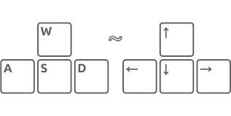

## 10.2 Game Camera

The camera is fixed in one spot behind the player.

## 10.2.1 HUD

The menu is displayed in the top right for easy access to quit the game. Collectables is displayed to the left of menu. Each round has a certain amount of collectables needed. Score is displayed at the end of the game. Time is displayed below the menu, resetting every level.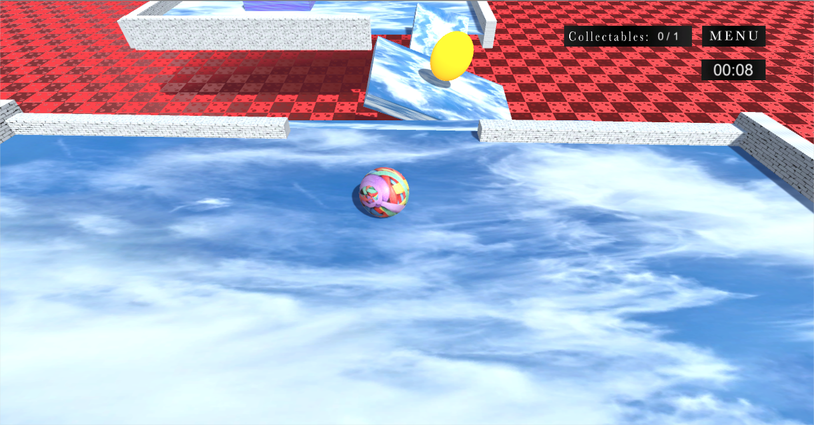

## 10.2.2 Maps

There is no map in the HUD.

# 11 Players

## 11.1 Characters

You are a rubber band ball.

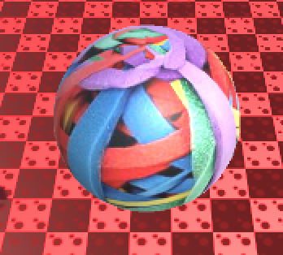

## 11.2 Metrics

Max health: infinite

Height 1 meter

## 11.3 States

Idle: you stand still.

Moving: you roll.

# 12 Player Line Up

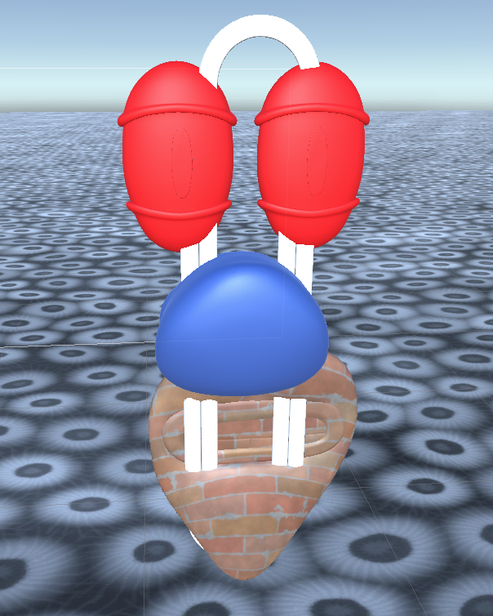

Rubber Band Ball Evil Boss

# 13 NPC

## 13.1 Enemies

The boss clippy is found at the end of the game.

## 13.1.1 Enemy States

The boss only has one state and that is the default idle state.

## 13.1.2 Enemy Spawn Points

The boss spawns above the final platform of the game.

## 13.2 Allies / Companions

There are no allies in this game.

## 13.2.1 Ally States

There are no allies in this game.

## 13.2.2 Ally Spawn Points

There are no allies in this game.

# 14 Art

## 14.1 Setting

Forgotten on the shelves of your owners home, you were transported into a magical world where you can live to your truest potential. This world spans through three different areas, a carpet terrain, an underwater and spongy territory, and an evil land with a big boss.

## 14.2 Level Design

The elements not on platforms don’t affect the gameplay since players are unable to interact with them. With this in mind the background was created as an aesthetic as possible to compliment the game. Obstacles created on the platforms are placed strategically to either hinder or benefit the players scores.

## 14.3 Audio

|  |  |  |
| --- | --- | --- |
| **Name** | **Category** | **Description** |
| Battle Fantasy! | Heatly Bros | Background Music For Levels |
| Dreams of Childhood | Heatly Bros | Background Music For Levels |
| Dream World! | Heatly Bros | Background Music For Levels |
| Island Village! | Heatly Bros | Background Music For Levels |
| Option Menu! | Heatly Bros | Background Music For Menu |
| HeartBeat Suspense | Aspecty | Background Music For Team Splash |

# 15 Procedurally Generated Content

## 15.1 Environment

None of the environment of this game was procedurally generated.

## 15.2 Levels

None of the levels of this game were procedurally generated.

## 15.3 Artificial Intelligence NPC

None of the AI of this game were procedurally generated.

## 15.4 Visual Arts

None of the visual arts of this game was procedurally generated.

## 15.5 Audio

None of the audio of this game was procedurally generated.

## 15.6 Minimum Viable Product (MPV)

* Soloplayer game with time based scoring system.
* Directional keys offer the player control of both platforms and players character.

# 16 Wish List

* Addition of skin variants for the players ball and maps.
* Implementation of a multiplayer mode where players can race alongside each other.
* Implementation of a live score display so players can actively track their score as they are playing.
* Implementation of a final collectibles display, showing the player how many total collectibles were collected and the total amount a collectibles that are possible.

# 

# 17 Asset Bibliography

## 17.1 Video Folder

* Fireworks.mp4, youtube.com

## 17.1.1 Animations Folder

* Credit Animation.anim, Tommy
* Credits.controller, Tommy
* Text1.controller, Tommy

## 17.1.2 Audio Folder

## 17.1.2.2 Sound Effects Folder

* SFX
  + Bounce.wav, <http://thebeautybrains.com/wp-content/uploads/podcast/soundfx/boing2.wav>
  + Confirm.mp3, <https://freesound.org/people/original_sound/sounds/372209/>
  + Synth_beep_02.ogg
  + Synth_laser_06.ogg
  + Synth_misc_06.ogg
  + Synth_misc_09.ogg

## 17.1.2.3 Soundtracks Folder

* Music
  + Credits.mp3, by the Heatley Bros
  + Instructions Hero’s Heart! Action anime RPG Music By HeatleyBros.mp3
  + Level 1 Dreams of Childhood.mp3, by the Heatley Bros
  + Level 2 Island Village! Happy Fun Game Music by HeatleyBros.mp3
  + Level 3 Battle Fantasy! Dreamy Action Game Music by HeatleyBros.mp3
  + Menu.mp3

## 17.1.3 Prefabs Folder

* Boom.prefab, Guillermo
* BossDeathSFX.prefab, Guillermo
* BossDeathSFX2.prefab, Guillermo
* ExplosionEffect.prefab, Guillermo
* ExplosionEffect1.prefab, Guillermo

## 17.1.4 Sprites Folder

* Ball, google.com
* Level 1 Floor, <https://3djungle.net/textures/sky/5928/>
* Level 2 Floor, <https://3dtextures.me/2019/10/28/coral-001/>
* Level 2 Wall, <https://3dtextures.me/2018/11/29/water-002/>

## 17.1.5 UI Folder

* BACK.png by Manuel
* Background.png by Manuel
* BGCol.png by Manuel
* Collectables_.png by Manuel
* MENU.png by Manuel

## 17.2 Scenes Folder

* Credits.unity by Lauryn
* Instruction.unity by Tommy, Lauryn
* Level 1.unity by Guillermo
* Level 2.unity by Manuel
* Level 3.unity by Lauryn, Tommy
* Menu.unity by Manuel, Guillermo

## 17.3 Scripts Folder

* BossController.cs, Lauryn
* CameraController.cs, Tommy
* Collectable.cs, Manuel
* Highscore.cs, Tommy
* MoveStage.cs, Tommy
* PlayerController.cs, Tommy
* RespawnScript.cs, Tommy
* Singleton.cs, Tommy
* StageButtonController.cs, Lauryn
* SwitchLevels.cs, Manuel
* UI_Controller.cs, Manuel
* VideoController.cs, Lauryn
* displayCollect.cs, Manuel
* displayTime.cs, Manuel